

**Title**: **Discuss the relationship among FT, DTFT, DFT, and z-transform**

**ID Number: 201424010116**

**Name: Raza Muhammad Ali**

***Abstract***:

***In this paper we discuss the relationship between Fourier transform (FT), discrete Fourier transform (DFT), discrete time Fourier transform (DTFT), and Z-transform. The Fourier transform (FT) is the method to convert function of time to function of frequency.  In the discrete Fourier transform (DFT) a finite list of equally spaced samples of a digital signal into the finite combination of complex sinusoids, according to their frequencies. The DFT is different from the discrete-time Fourier transform (DTFT) because it’s input and output sequences are both finite, but DTFT may have infinite sequences. However some signals also exist whose Fourier transform is not possible, so for these type of signals we use Z-transform, which converts signal in frequency domain but different in that we replace complex exponential by z-domain analysis. So we will use mathematical equations to show the relation between DT, DFT, DTFT, and Z-transform.***

1. ***Introduction:***
   1. **Fourier transform (FT)**

The **Fourier transform** is a method of converting the signal from time domain to frequency domain by the given formula; I we have signal g (t) we can get G (f) by equation 1.1. [1]

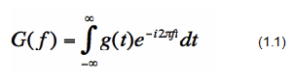

* 1. **Discrete Fourier transform** (**DFT**)

 The **discrete Fourier transform** (**DFT**) converts a finite list of equally spaced samples of a digital signal into the sequence of coefficients of a finite combination of complex exponentials ordered by their frequencies. It can be said to convert the digital signal from its time domain to the frequency domain. DFT has finite input and output sequences. If we have discrete signal x[n] then we get DFT as in given equation 1.2. [2]

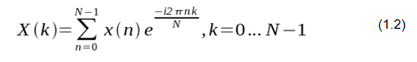

* 1. **Discrete-time Fourier transform (DTFT)**

 In the **discrete-time Fourier transform (DTFT)** the uniformly-spaced samples of a continuous function are transformed. The term *discrete-time* refers to the fact that the transform operates on discrete data (samples) whose interval has units of time. [2] From only the samples, it produces a function of frequency that is a periodic summation of the continuous Fourier transform of the original continuous function. DTFT itself is a continuous function of frequency, but discrete samples of it can be readily calculated via the Discrete Fourier Transform (DFT). [3] DTFT can be calculated by, If we have discrete signal x[n] then we get DTFT as in given equation1.3

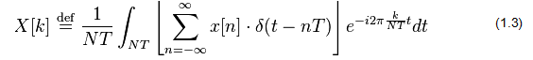

* 1. **Z-Transform:**

The signals whose Fourier transform is not possible we use z-transform,  the **Z-transform** converts a discrete-time signal, which is a sequence of real or complex numbers, into a complex frequency domain representation. [4] We replace complex exponential I DFT by a term z, as by z=ejw. . If we have discrete signal x[n] then we get Z-transform as in given equation 1.4

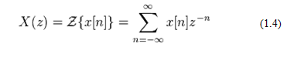

So we can write

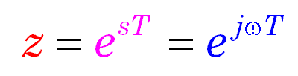

**2. Relation between FT, DFT, DTFT, and Z-transform:**

We are going to discuss relation between FT, DTFT, DFT and z-transform. We have already know definitions of all these transforms so we can calculate that  e^{-i 2\pi f T n}  is the Fourier transform of  \scriptstyle \delta(t-nT).  Therefore, an alternative definition of DTFT is**:**

|  |  |
| --- | --- |
| X_{1/T}(f) = \mathcal{F}\left \{\sum_{n=-\infty}^{\infty} x[n] \cdot \delta(t-nT)\right \} | (1.5) |

In DTFT sequence is infinite When the input data sequence *x*[*n*] is *N*-periodic and has finite sequence,[5] **Equation 1.5** can be computationally reduced to a **discrete Fourier transform (DFT)**, because**:**

* All the available information is contained within N samples.
* So DTFT converts to DFT when sequence becomes finite

**2.1. FT and DFT are same but signals nature different:**

Fourier transform (FT) is the method to convert continuous signals from time domain to frequency domain.[6] Discrete Fourier transform (DFT) is method to convert discrete signals from their samples at discrete values to complex frequency exponentials.[7] Hence both are same but signals nature differs in both cases. As by given formulas

FT

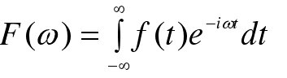

DFT

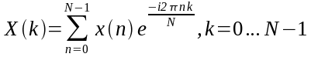

So from above formulas it is clear that FT and DFT both are same but DFT is for discrete signals and FT is for continuous signals.[8]

**2.2. If we choose Periodic signal DTFT becomes DFT**

In DTFT sequence is infinite. When we select *N*-periodic data and DTFT reduced to a **discrete Fourier transform (DFT). [9]** In case of periodic signals because of periodicity, we can reduce the limits of summation to any sequence of length N, without losing any information. The result is just a DFT. If we have equation

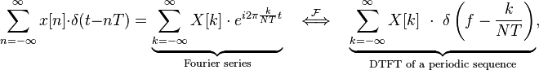

Which also shows that periodicity in the time domain causes the DTFT to become conveniently reduces to a DFT**:**

\begin{align}
X[k] \ &\stackrel{\text{def}}{=}\ \frac{1}{NT} \int_{NT} \left[\sum_{n=-\infty}^{\infty}x[n]\cdot \delta(t-nT)\right] e^{-i 2 \pi \frac{k}{NT}t} dt \quad 
\scriptstyle {\text{(integral over any interval of length NT)}} \displaystyle \\
&= \frac{1}{NT} \sum_{n=-\infty}^{\infty} x[n]\cdot \int_{NT} \delta(t-nT)\cdot e^{-i 2 \pi \frac{k}{NT}t} dt \\
&= \frac{1}{NT} \underbrace{\sum_{N} x[n]\cdot e^{-i 2 \pi \frac{k}{N}n}}_{DFT} \quad \scriptstyle {\text{(sum over any n-sequence of length N)}} \\
&= \frac{1}{N} \underbrace{\sum_{N} x(nT)\cdot e^{-i 2 \pi \frac{k}{N}n}}_{DFT},
\end{align}

which is an N-periodic sequence (in **k**) that completely describes the DFT.[10] So DTFT is related to DFT by this way.

**2.3. When DTFT is continuous periodic then choosing one cycle gives DFT.**

When the DTFT is continuous, we have number of samples (N) of one cycle of the periodic function *X1/T [11]*: As shown by following equations

\begin{align}
\underbrace{X_{1/T}\left(\frac{k}{NT}\right)}_{X_k} &= \sum_{n=-\infty}^{\infty} x[n]\cdot e^{-i 2\pi \frac{kn}{N}} \quad \quad k = 0, \dots, N-1 \\
&= \underbrace{\sum_{N} x_N[n]\cdot e^{-i 2\pi \frac{kn}{N}},}_{DFT}\quad \scriptstyle {(sum\ over\ any\ n-sequence\ of\ length\ N)}
\end{align} 

So by choosing one cycle we have DFT.

**2.4. Z-transform and DFT:**

There are some signals whose Fourier transform is not possible such as non periodic, increasing, decreasing so for these type of signals we use Z-transform instead of FT. [12] we replace complex exponential by z parameter as given below

Z=℮jw

So z-transform and DTFT are same as given below

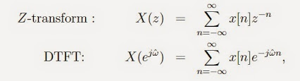

**Conclusion:**

The above discussion can be reduced to following result:

**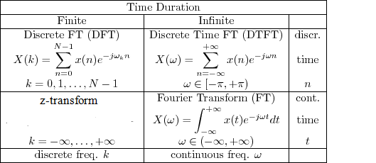**

**Z-Transform**

$$X(k)=\sum_{n=0}^{N-1}{{x[n]z}^{-n}}$$

From above discussion we conclude that FT, DFT, DTFT and Z transform are all same but the different is that we use FT to convert continuous signal from time domain to frequency domain. For discrete signals we use DFT and DTFT. The main difference between DFT and DTFT is that In **DTFT** the uniformly-spaced samples of a continuous function are transformed. The term *discrete-time in DTFT* refers to the fact that the transform operates on discrete data (samples) whose interval has units of time. And in DTFT the discrete sequence is infinite but in DFT finite sequence is converted in frequency domain. DFT and Z-transform both are same but Z-transform is valid for all type of signals like periodic, non-periodic, signals having infinite or finite energy, but DTFT is valid only for periodic signals having finite energy. So all are related to each other.

**References:**

[1] VanValkenburg, M.E., *Network Analysis*, 3rd ed., Englewood Cliffs, NJ: Prentice-Hall, 1974.

[2] Oppenheim, A.V., Willsky, A.S., and Young, I.T., *Signals and Systems*, Englewood Cliffs, NJ: Prentice-Hall, 1983.

[3] Brace well, R.N., *The Fourier Transform*, 2nd ed., New York: McGraw-Hill, 1986.

[4] Oppenheim, A.V. and Schafer, R.W., *Discrete-Time Signal Processing*, Englewood Cliffs, NJ: Prentice-Hall, 1989.

[5] Jenkins, W.K. and Desai, M.D., The discrete-frequency Fourier transform, *IEEE Trans. Circuits Syst.*, vol. CAS-33, no. 7, pp. 732–734, July 1986.

[6] Oppenheim, A.V. and Schafer, R.W., *Digital Signal Processing*, Englewood Cliffs, NJ: Prentice-Hall, 1975.

[7] Blahut, R.E., *Fast Algorithms for Digital Signal Processing*, Reading, MA: Addison-Wesley,

1985.

[8] Deller, J.R., Jr., Tom, Dick, and Mary discover the DFT, *IEEE Signal Processing Mag.*, vol. 11, no. 2, pp. 36–50, Apr. 1994.

[9] Burros, C.S. and Parks, T.W., *DFT/FFT and Convolution Algorithms*, New York: John Wiley and Sons, 1985.

[10] Brigham, E.O., *the Fast Fourier Transform,* Englewood Cliffs, NJ: Prentice-Hall, 1974.

[11] William McC. Siebert (1986). *Circuits, Signals, and Systems*. MIT Electrical Engineering and Computer Science Series. Cambridge, MA: MIT Press